Synopsis

On

“Weather Forecasting & Disaster System Prediction Using AI”

Submitted By

Ms. Suchita Mishra

Ms. Vaishnavi Belekar

Ms. Shubhangi Chaudhary

Mr. Pushpak Fasate

Mr. Utkarsh Hajare

### Under the Guidance of

Dr. Mrudula Nimbarte



**Department of Computer Science & Engineering**

**S. B. Jain Institute of Technology Management and Research, Nagpur-441501**

**2019-2020**

**CONTENTS**

1. Introduction 3

2. Problem Statement & Objectives 4

3. Literature Survey 5

4. Flow Chart 11

5. Use Case Diagram 12

6. Proposed Work 12

7. Technology 13

8. Applications 13

9. Expected Project Outcomes 14

10. Reference 14

# Introduction

Over the last decade, more than 2.6 billion humans have suffered from catastrophic disaster outbreaks such as tsunamis, floods, earthquakes, cyclones and landslides, and various pandemics. Disasters have been the cause of several fatalities in the past, one of the deadliest disasters was an earthquake in New Guinea which left around 58, 300 people displaced according to the displacement tracking matrix

India, the second most populated country in the world, is highly exposed to natural disasters. Due to its geographical location, seismic risk zone and intertropical convergence point, the Indian subcontinent also faces recurring atmospheric phenomena: heavy monsoon rains, floods, episodes of high heat, drought, etc.

In addition, the high population density in risk areas further aggravates the situation. The number of human casualties continues to rise, from 1674 deaths in 2015 to 2045 in 2019. According to the report of the United Nations Office for Disaster Risk Reduction (UNDER), the total number of people who died between 2000 and 2019 is 79 732.

During the same period, India had reported 321 catastrophic events. It is the third country in the world in terms of the number of natural disasters, behind China and the United States. According to the same report, India has suffered nearly 80 billion USD in economic losses in 20 years.

To date, many people have suffered greatly because of the lack of a proper disaster and pandemic management system. A proper prediction of a disaster could not be done, and victims were not evacuated on time from the disaster outbreak area. People were not provided with mitigation measures post-disaster. Also, during the pandemic, efficient steps could not be followed to prevent further spread of the outbreak. To address such issues like flood, earthquake, cyclone, tsunami provides a detailed review of all the existing procedures and techniques that can be employed during the post, and pre-disaster period to minimize the losses as much as possible.

# Problem Statement & Objectives

Disasters are one of the major concerns for the economic loss and damage in any country. If the disasters can be predicted at an early stage, the damage and loss of the country could be reduced to an extent and natural resources can also be protected.

So we aim at providing an app in which we include the weather forecasting as well as the disaster predictions.

### Objectives

* To effectively forecast real time weather and to strengthen disaster prediction mechanisms.
* Reduce the risk of disasters caused by human error, deliberate destruction, and building or equipment failures
* Reducing the damage, death, sufferings and destruction of any natural and human induced disaster.
* To compare and evaluate the performance of above models and the programming was carried out using MATLAB as a tool

# Literature Survey

|  |  |
| --- | --- |
| **Websites / Paper / Article** | **Reviews / Findings** |
| Weather 1 | It is an animated and accurate weather forecasting app.    Findings :   * User friendly interface. * Have too many ads in it. |
| Weather 1.1 | It is a real-time weather app that professionally and accurately display data.  Findings :   * Forecast is not satisfactory for the users. |
| Disaster Alert | It is an app which provides early warning about natural hazards.    Findings:   * User friendly * Update hazards after its occurrence. |
| Disaster Prediction | It is an info and alert system on two studies of solar influence over the earth.  Findings:   * Requires subscription to use the app. |
| Earthquake Alert | An app which shows the latest earthquakes from all over the world.    Findings:   * Provides information about the latest earthquakes. |
| Flood Forecasting & Warning Center | It is a flood forecasting, flash flood and warning system of Bangladesh.  Review:   * UI is not user friendly. |

**Similar Applications:**

1.Weather 1 2. Weather 1.1

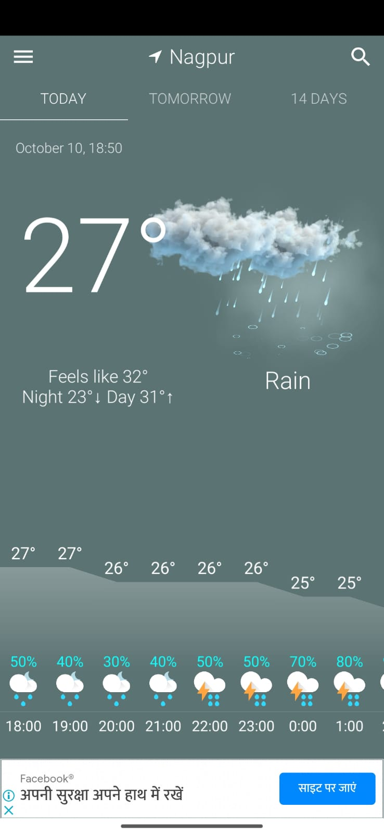 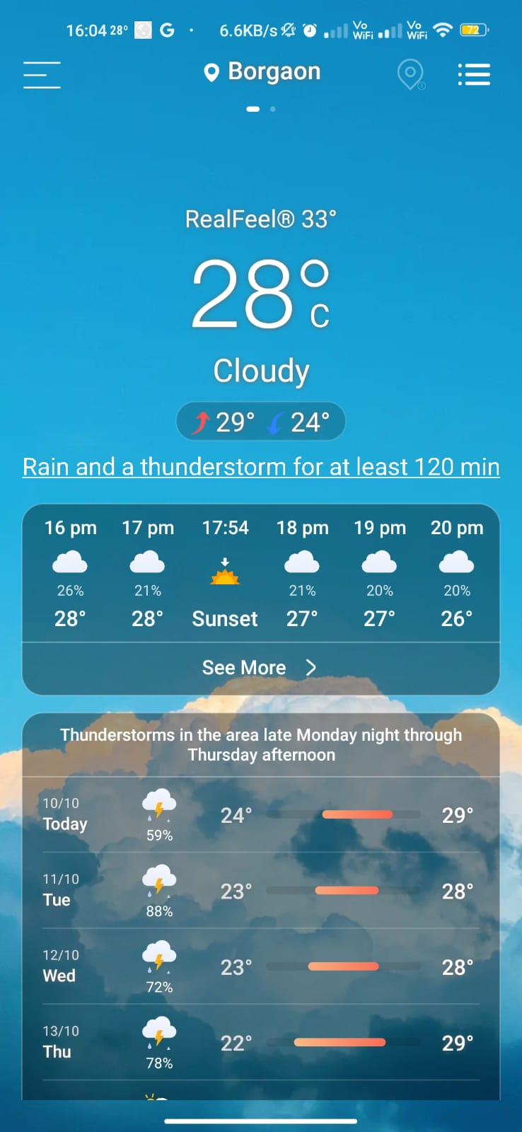

1. Disaster Alert

 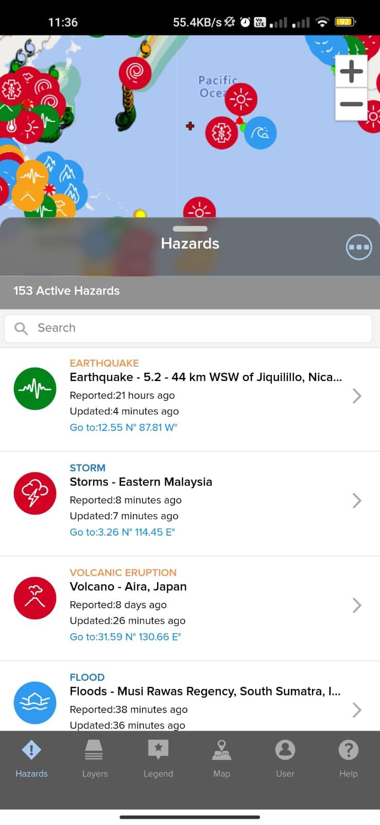

2. Disaster Prediction

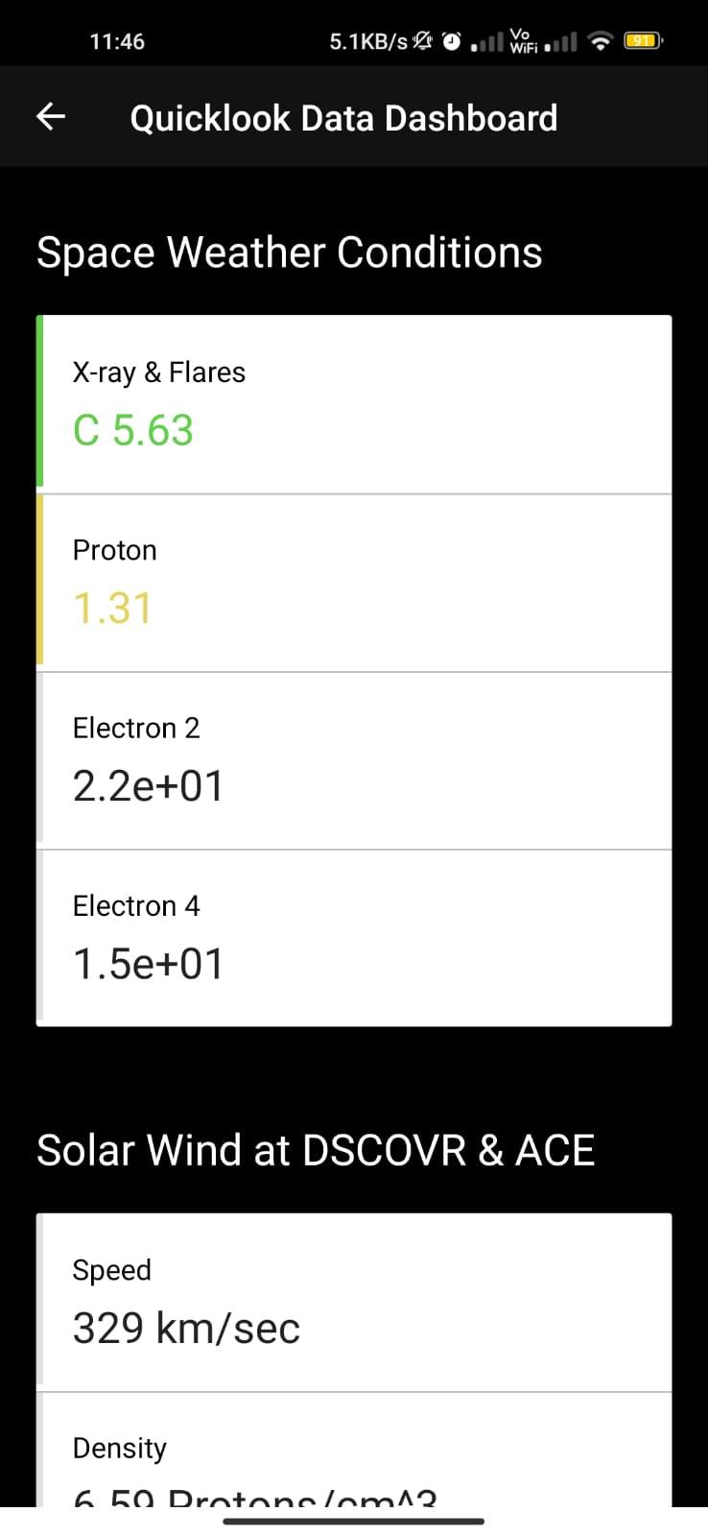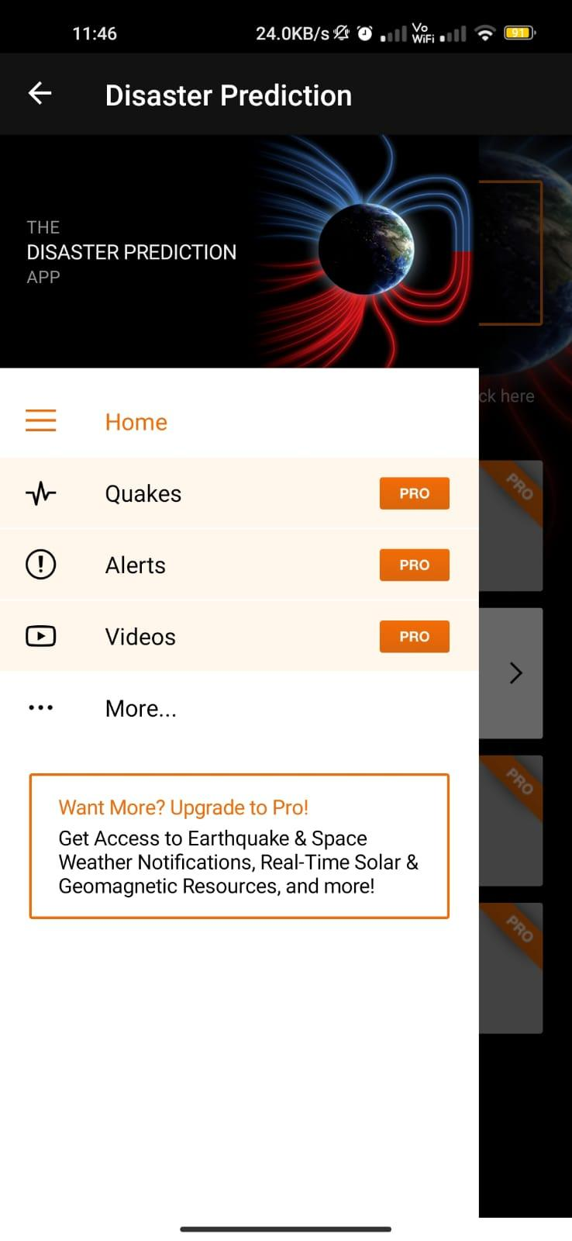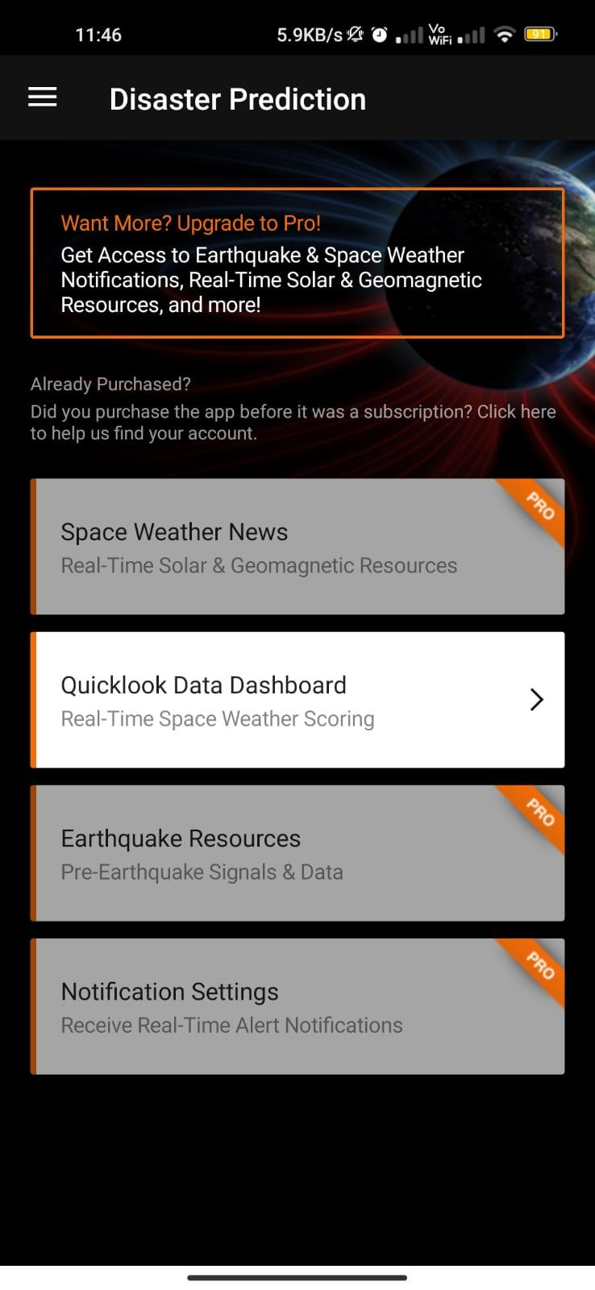

3. Earthquake Alert 4. Flood Forecasting & Warning Center

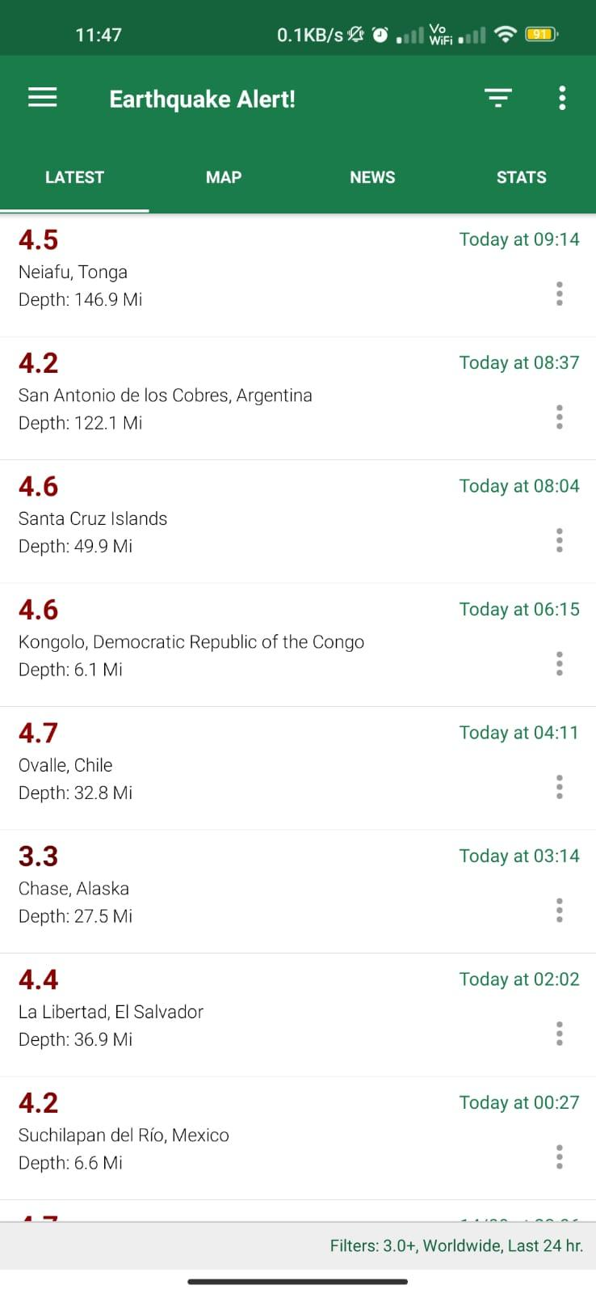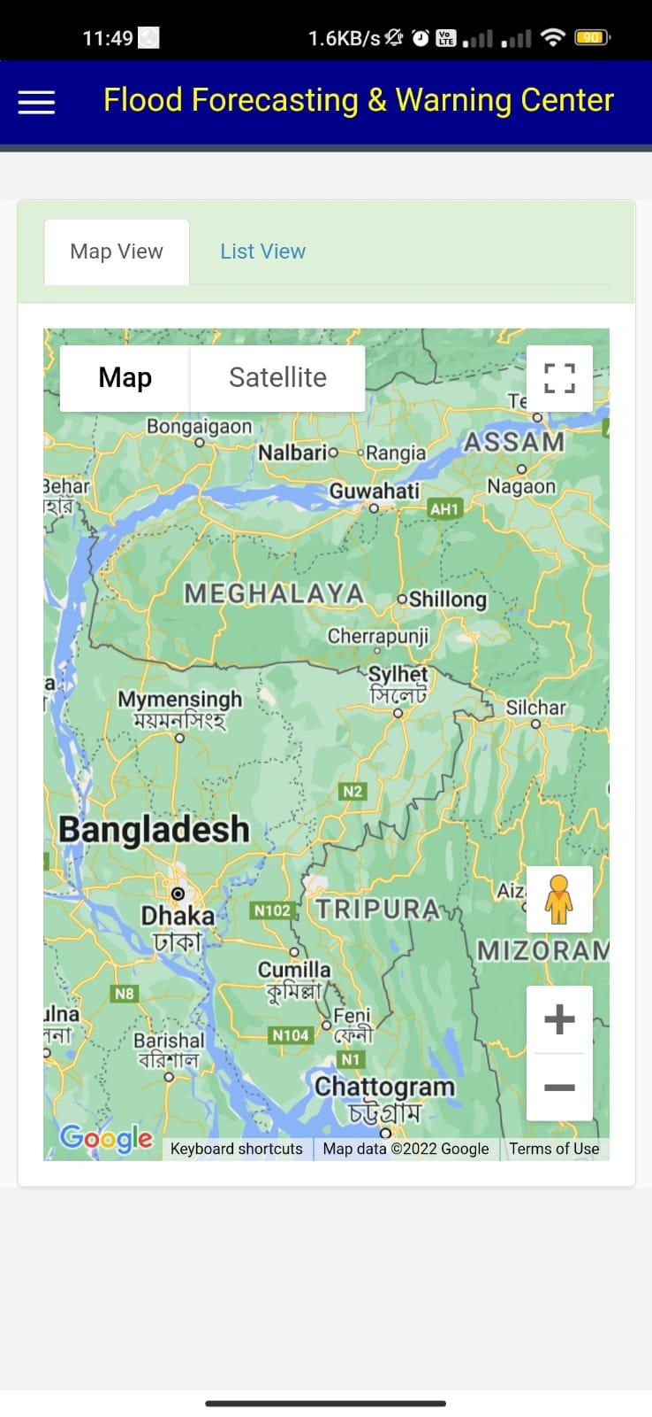

**Screenshots**

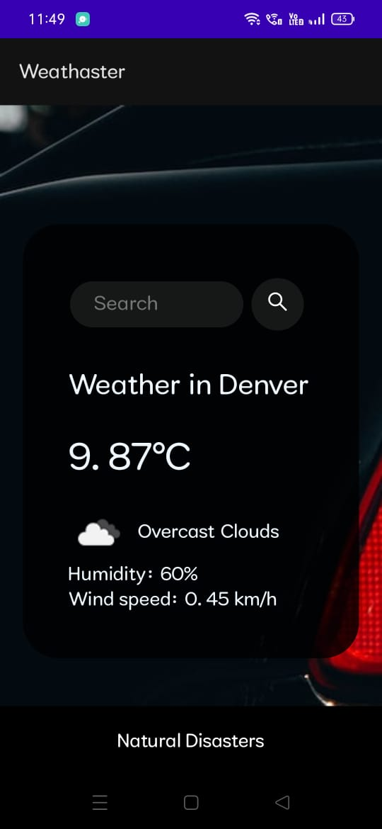 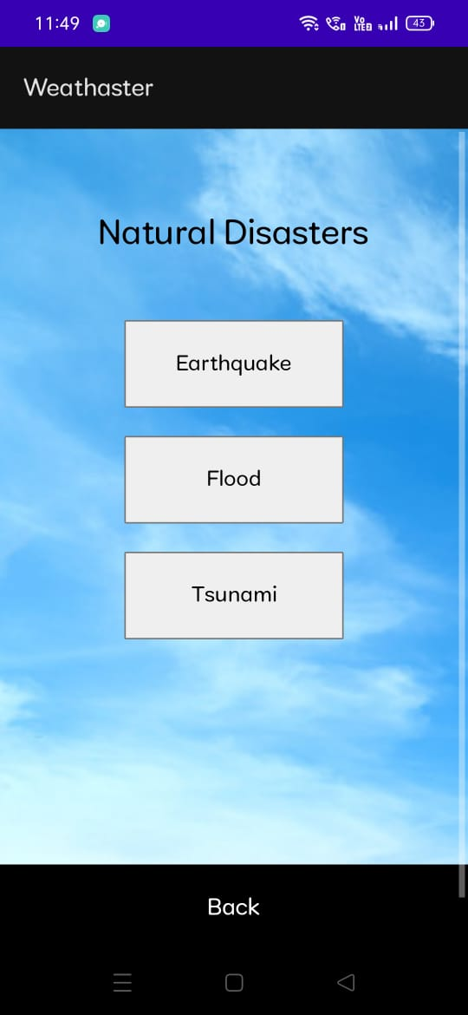

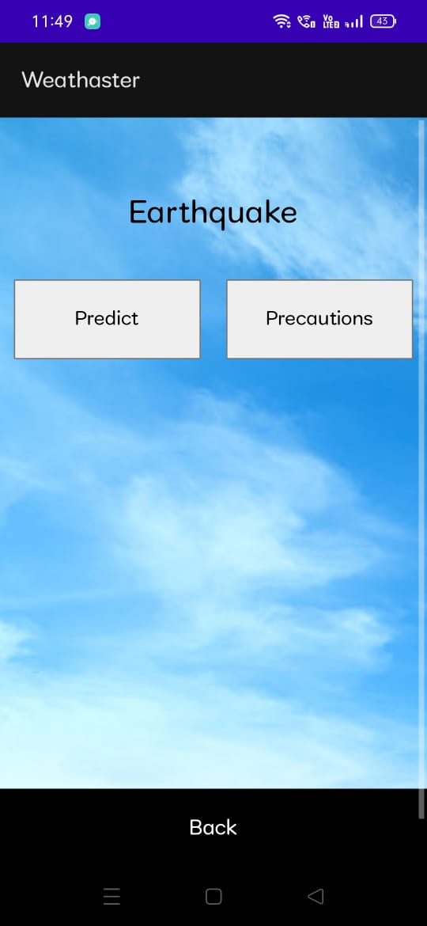

1. **Flowchart**

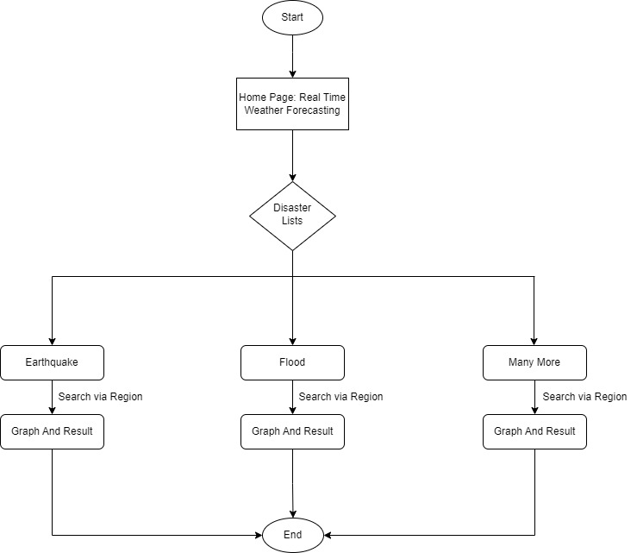

1. **Use Case Diagram**

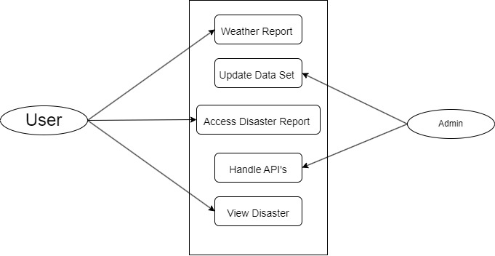

# 

# Proposed Work

The main purpose of this project is to provide users the real time **Weather Forecasting** based on the area and in addition to this, it will also let users see the **future predictions for any kind of disasters** along with a graph of past year’s data.

Weather forecasting is the application of science and technology to predict the state of the atmosphere for a given location. Weather forecasts are made by collecting quantitative data about the current state of the atmosphere and using scientific understanding of atmospheric processes to project how the atmosphere will evolve. There are a variety of end users to weather forecasts. Weather warnings are important forecasts because they are used to protect life and property.

### Modules:

1. Weather Forecasting
2. Disaster Predictions

# Technology

### Front End:

* 1. HTML,
  2. CSS
  3. Java Script

### Backend:

* 1. Py-script
  2. Datasets

# Applications

* + It will forecast real time weather.

### It will predict the chances of any kind of disaster in future.

### Advantages –

* It is free to use.
* User friendly.
* Accurate in forecasting and prediction

# Expected Project Outcomes

We will develop an app, in which there will be real time weather forecasting and disaster prediction for the near future. We will apply **engineering knowledge** to **analyze this problem** and provide a modern engineering solution. Then we will **design** the application in two modules. We will **investigate** the available applications to find out the new solutions and updates. We will use **Machine Learning & Deep Learning algorithms** toimplement the logic for this app. During this project tenure we will apply **professional ethics** and will understand the importance of **team work** and **communication** while presenting projects in various competitions and conferences for **project management**, which leads us to engage ourselves in **lifelong learning**.

# REFERENCES

## **Papers/Journals:**

1. A. Brighente, F. Formaggio, G. M. Di Nunzio, and S. Tomasin, “Machine learning for in-region location verification in wireless networks,” IEEE Journal on Selected Areas in Communications, vol. 37, no. 11, pp. 2490–2502, 2019.
2. J. H. Samuel Lalmuanawma and L. Chhakchhuak, “Applications of machine learning and artificial intelligence for covid-19 (sars-cov-2) pandemic: A review,” Chaos, Solitons Fractals, vol. 139, p. 110059, 2020.

## **Websites:**

<https://www.ualberta.ca/science/news/2020/march/machine-learning-disaster-prediction.html#:~:text=The%20scientists%20are%20using%20machine,as%20a%20landslide%20or%20earthquake>

|  |  |  |
| --- | --- | --- |
| **Sr No** | **Group Members Name** | **Sign** |
| 1 | Suchita Mishra |  |
| 2 | Vaishnavi Belekar |  |
| 3 | Shubhangi Choudhary |  |
| 4 | Pushpak Fasate |  |
| 5 | Utkarsh Hajare |  |

|  |  |  |
| --- | --- | --- |
| **Sr No** | **Guide Name / Co Guide Name** | **Sign** |
| 1 | Dr. Mrudula Nimbarte |  |